# Create a simple form using HTML

**Program:**

<html>

<head>

<title>Create a form</title>

</head>

<body>

<h1>Form</h1>

<form>

<label for=name>Name :</label>

<input type="text" name="name"/><br><br>

<label for=email>E Mail :</label>

<input type="text" name="email" size="30"><br><br>

<label for=mno>Mobile No :</label>

<input type="text" name="mno" size="10"><br><br>

<label for=City>City :</label>

<input type="text" name="City"/><br><br>

<label for=State>State :</label>

<select name="State" style="width: 150px">

<option value="Tamil nadu">Tamil nadu</option>

<option value="Kerala">Kerala</option>

<option value="Chennai">Chennai</option>

<option value="Bangalore">Bangalore</option>

</select><br><br>

<label for=country>Country :</label>

<select name="country" style="width: 150px">

<option value="America">America</option>

<option value="Bangladesh">Bangladesh</option>

<option value="Canada">Canada</option>

<option value="India">India</option>

</select><br><br>

<input type="submit" value="Submit">

<input type="reset" value="Reset">

</form>

</body>

</html>

# Output:

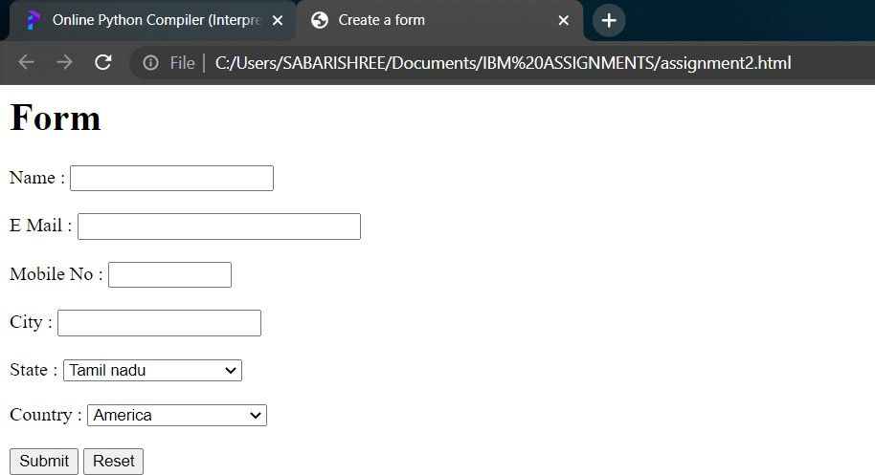

Submitted by

Yogesh P

Sunil I

Sridevi M I

Vishnu Murugan

Mahalingam M